East Sussex Fire and Rescue Service

Sample Messaging Grid
The aim of the project was to prevent and therefore reduce the amount of accidental dwelling fires after someone has been on a night out drinking alcohol.

Week commencing… | Control group | Intervention group
29th Oct | Is Mac n cheese the best?
Why does the journey home always take longer in the cold and dark? But oh... the joy of comfort food waiting for you.
What’s your ‘prepare ahead’ dish?
Mac n cheese…. Oh yes!
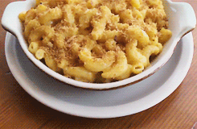
#BrightonTribe
5th Nov | Fire up the grub!
 | *** NO MESSAGE TO CONTROL GROUP *** | Remember, remember the 5th of November: ready meals, deliveries and fries…. Ok, so that’s not quite how the rhyme goes but bonfire night is a busy time for the fire service. Avoid us arriving at your house for an unforeseen incident by sorting your grub before the merriment begins!  And to get you in the mood…What’s a fire fighters favourite bonfire grub? Bangers and mash!
12th Nov | Free pizza, anyone?
We love pizza, who doesn’t? And this month we have got a £25 Pizza Face voucher to give away for one lucky member of our #BrightonTribe. Will it be you?
We’ll be notifying one lucky winner very soon!
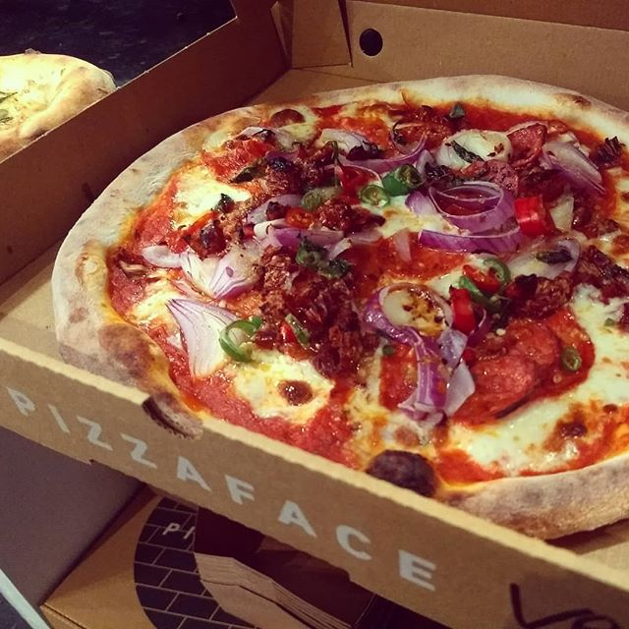
15th Nov | Set your tastebuds on fire
The winner of the #BrightonTribe prize draw this month is <insert name>, who wins a wicked £25 Pizza Face voucher. Look out for the next prize up for grabs in December!
Extra jalapeno’s? That the kind of fire we like!
19th Nov | Easy does it…
 | *** NO MESSAGE TO CONTROL GROUP *** | With twinkly lights and stores getting ready for festive fun its hard to believe there’s still over 5 weeks until Christmas. Pace yourself – we’re in this for the long haul.  A few days alcohol free will improve your sleep and save those £££s. And a pre-prepared snack will satisfy late night munchies. With a bit of planning you’ll make it through the season with cash in your pocket and a spring in your party shoes.
26th Nov | Eat the world in BN1
Is it pay day yet? We’re thinking its time for a take away. We’ve got over 400 restaurants in Brighton. So what’ll it be?

3rd Dec | Can we open the tub of sweets?
 | *** NO MESSAGE TO CONTROL GROUP *** | Is it too early to break out the Christmas chocs? Maybe… but its always a good time to practice those party tricks. Ah yes, Popcorn catching. What’s yours? Tweet us @EastSussexFRS and we’ll RT our faves!  
10th Dec | Party time is hotting up
Office parties are in full swing…. But eurgh… the aftermath! Make sure you’re prepared with water beside your bed and a stomach-settling snack ready for when you get home. Much better than attempting to cook after a night out!
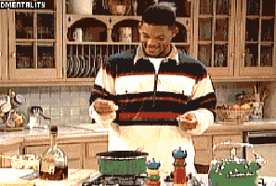
17th Dec | Free cinema tickets? Nice.
Winner, winner, turkey dinner

We have an early Christmas present for <insert name> who is the winner of this month’s prize of a £20 voucher for Cineworld.
#BrightonTribe
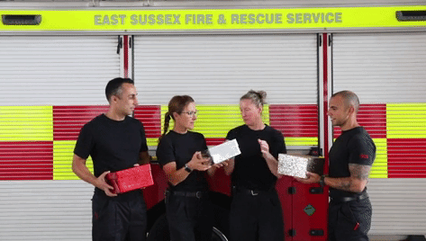
24th Dec | One more sleep
OK, calm. You’ve made it through December and the big day is here.
after tomorrow there’s no more cooking to be done. Movies, mince pies and left overs…
And breathe….
#BrightonTribe Making sure great days are followed by great nights!

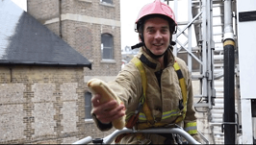
31st Dec | An essential life rule…
 | *** NO MESSAGE TO CONTROL GROUP *** | New year, new you? New year’s resolutions… fitness, lifestyle… they don’t always last. But there’s one rule that will stand you in good stead all year round: No cooking after a heavy night. Its always better to have a snack ready or a takeaway on speed dial… Happy New Year!  #BrightonTribe We’re your crew.  