


Professionalisation of Housing Survey
Research Report
June 2023

To view more research from the Local Government Association Research and Information team please visit: https://www.local.gov.uk/our-support/research

Contents
Professionalisation of Housing Survey 1
Contents 3
Summary 1
Background 1
Key messages and findings 1
Introduction 2
Methodology 2
Professionalisation of housing survey 5
Numbers of staff already and not yet sufficiently qualified 5
Estimates of timescale for gaining the required qualifications 8
Estimated additional cost to local authorities 8
Disruptive impacts on recruitment and service delivery 10
Disruptive impacts on service provision 12
Other potential barriers or issues 14
Annex A: Questionnaire 15

Summary

Background
In May to June 2023, the LGA’s Research and Information Team circulated an online survey to Directors of Housing at English local authorities which own housing stock. The purpose of the survey was to assess the potential impact of the introduction of new standards being introduced for the professionalisation of the housing sector, which will require senior housing officers to be qualified to a certain level. Of the 259 applicable local authorities, a total of 42 replied – a response rate of 16 per cent.

Key messages and findings
- A total of 66 per cent of senior housing managers at respondent councils were not yet sufficiently qualified to meet the new requirements, and 54 per cent of senior housing executives likewise require further qualifications.
- A total of 62 per cent of respondents reported that they would not feasibly be able to ensure 100 per cent compliance with the required level of qualifications within a two-year period, given their current resources.
- Based on financial figures provided by the respondents, English councils are likely to face £17.9 million in additional costs resulting directly from these requirements for the first two years, and £3.7 million per annum on an ongoing basis after the end of the first two years.
- A total of 80 per cent of respondents anticipated great or moderate disruptive impacts on their recruitment and retention of housing officers as a result of the requirements.
- A total of 68 per cent of respondents anticipated a disruptive impact on their service provision as a result of the requirements.

Introduction
In May to June 2023 the Local Government Association (LGA) conducted a survey of Directors of Housing across all councils in England. This survey was undertaken in response to new standards for the professionalisation of the housing sector originating from Amendment 13 of the Social Housing (Regulation) Bill, which requires senior housing management staff to complete qualifications up to a certain level. The aim of the survey was:
- To gauge the number of local authority housing staff who are already sufficiently qualified, and the number who will need to complete additional qualifications
- To estimate how long it might reasonably take for local authorities to support their staff to achieve the required qualifications
- To estimate the likely cost to local authorities of doing this, including the one-off cost of qualifying their existing staff to the required level and the ongoing annual cost of ensuring that staff are qualified to this level in future
- To assess whether local authorities anticipate any negative impact on recruitment and retention and/or service provision as a result of these requirements
- To gather intelligence on the precise nature of any obstacles to qualifying housing staff to the required level, and suggestions for how these obstacles can be overcome

Methodology
In May 2023, the LGA’s Research and Information Team sent an online survey to the Directors of Housing of all English councils which retain directly owned housing stock. This included 259 local authorities, which collectively own approximately 1.59 million housing properties. Local authorities which did not directly own housing stock were not included in the survey.
Of the 259 authorities who were invited to take part in the survey, a total of 42 replied – a response rate of 16 per cent. This level of response rate means that these results should not be taken to be more widely representative of the views of all councils. Rather, they are a snapshot of the views of this particular group of respondents.
Ownership of housing stock differed considerably between local authorities, with some large urban authorities owning tens of thousands of properties, and some owning only a handful. Table 1 below shows the number of councils within each broad band of stock ownership volume, demonstrating that a reasonable number of responses were received from councils at all levels of stock ownership, with a particular concentration of responses from councils owning very high and moderate volumes of housing stock. In total, of the 1.59 million directly owned council housing properties, councils owning approximately 364,000 properties responded to the survey, thus covering approximately 23 per cent of these properties. The average number of properties owned per council was approximately 5,000.
Table 1: Breakdown of response rate by amount of housing stock owned
Amount of housing stock owned | Total number | Number of responses | Response rate  %
More than 20,000 | 20 | 6 | 30
10,001 to 20,000 | 35 | 4 | 11
5,001 to 10,000 | 53 | 12 | 23
1,001 to 5,000 | 57 | 10 | 18
1,000 or less | 96 | 10 | 10
Table 2 shows a breakdown of the response rate by type of authority. This shows that similar levels of responses were received across each authority type among those owning housing stock. The response rate was lowest among district councils, largely because of the large number of these councils which own housing stock. However, districts tend to own smaller volumes of stock per council, with the average amount of stock owned for districts at just over 2,300 properties per council, compared to the overall average of approximately 5,000 per council. The response rate was highest among London boroughs and metropolitan districts, which tend to be located in densely populated urban areas with high volumes of housing stock.
Table 2: Breakdown of response rate by type of authority
Type of authority | Total number owning housing stock | Number of responses | Response rate  %
District | 154 | 20 | 13
London borough | 32 | 8 | 26
Metropolitan district | 29 | 8 | 28
Unitary | 40 | 6 | 15
Table 3 shows a breakdown of the response rate by region. This shows that a reasonable level of response was received for each region of England, although the North West and South East had less than ten per cent of their stock-owning councils take part. The North East, Greater London and Yorkshire and the Humber had the highest response rates, at 22 per cent, 26 per cent and 32 per cent respectively.

Table 3: Breakdown of response rate by region
Region | Total number owning housing stock | Number of responses | Response rate  %
Eastern | 41 | 7 | 17
East Midlands | 32 | 4 | 13
Greater London | 31 | 8 | 26
North East | 9 | 2 | 22
North West | 26 | 2 | 8
South East | 52 | 4 | 8
South West | 25 | 5 | 20
West Midlands | 24 | 4 | 17
Yorkshire and Humber | 19 | 6 | 32
In addition, the following points should be noted about the research methodology:
- Where tables and figures report the base, the description refers to the group of people who were asked the question. The number provided refers to the number of respondents who answered each question”, with the option of adding as appropriate “please note that bases vary throughout the survey.
- Some calculations in this report extrapolate estimated costs from the respondents, applying them to all stock-owning councils to estimate total anticipated costs across England. The reliability of these estimates rests on the assumption that estimated costs among non-respondent councils are roughly equivalent to those which provided responses, which, by definition, cannot be proven. However, the relatively even distribution of responses by region, authority type and volume of housing stock support the validity of these calculations, and extrapolated estimates have been rounded down for the sake of caution to err on the conservative side.
- Throughout the report percentages in figures and tables may add to more or less than 100 per cent due to rounding.

Professionalisation of housing survey
This section contains analysis of the full results from the survey.

Numbers of staff already and not yet sufficiently qualified
Respondents were asked to provide the number of staff already qualified to the required level, and the number of staff not yet sufficiently qualified. They were asked for these numbers separately for two types of senior housing officers: senior housing managers and senior housing executives.
Table 4 and Figure 1 show the results for this question. This demonstrates that, of the 566 senior housing managers reported by the 42 respondent councils, 192 (approximately 34 per cent) were already qualified to the required level, whilst the remaining 374 (66 per cent) were not yet qualified to this level. Of the 176 senior housing executives reported by the respondents, 81 (46 per cent) were already sufficiently qualified, whilst the remaining 95 (54 per cent) were not yet sufficiently qualified. This shows that for both roles, a majority of housing officers were not yet sufficiently qualified, although the percentage already qualified was considerably closer to half among senior housing executives than among senior housing managers.
Table 4: Senior housing officers already or not yet sufficiently qualified
 | Number | Per cent
Senior housing managers
Already sufficiently qualified | 192 | 34
Not yet sufficiently qualified | 374 | 66
Total | 566 | 100
Senior housing executives
Already sufficiently qualified | 81 | 46
Not yet sufficiently qualified | 95 | 54
Total | 176 | 100
Base: all respondents (42 respondents).

Figure 1. Workforce already and not yet sufficiently qualified
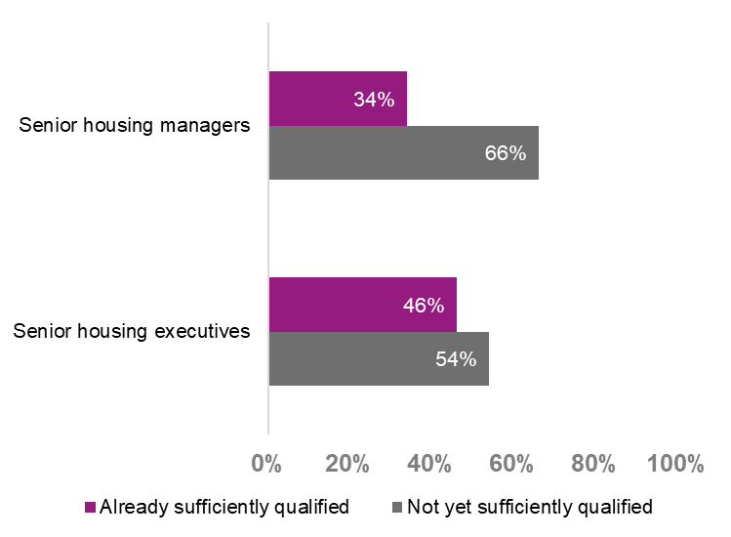
Respondents were then asked how confident they were in the accuracy of the numbers of housing officers they had provided – in estimating both the total number provided and in their current level of qualification and whether that level is sufficient to meet the requirements.
Table 5 shows the results for this question. This demonstrates that 70 per cent of respondents were either very or fairly confident in the number of qualified housing officers that they provided. This included 23 per cent of respondents who were very confident, and 47 per cent who were fairly confident. However. 23 per cent of respondents were not very confident in their estimates, and five per cent were not at all confident in them.

Table 5: How confident are you that you have accurately estimated the number of qualified housing officers above?
 | Number | Per cent
Very or fairly confident | 30 | 70
Very confident | 10 | 23
Fairly confident | 20 | 47
Not very confident | 10 | 23
Not at all confident | 2 | 5
Don’t know | 0 | 0
Base: all respondents (42 respondents).
Those respondents who selected “not very confident” or “not at all confident” were given an additional, open text question which asked them to explain this lack of confidence, and what they might need to achieve greater certainty. Eleven respondents provided answers to this question, and highlighted the following issues, although not every respondent mentioned every issue:
- Lack of clarity or awareness on what constitutes a “senior housing executive” or “senior housing manager.”
- Lack of clarity over the division between officers funded by the Housing Revenue Account (HRA) and General Fund.
- Lack of clarity caused by fragmentation of roles across council departments, for example, those in Customer Service, and uncertainty over whether roles in non-housing related departments are within scope or whether the legislation relates only to tenancy management staff.
- Lack of clarity on what qualifications are considered sufficient, especially relating to historic qualifications gained decades previously, and Chartered Institute fellowships and qualifications. Respondents mentioned a wide proliferation of different types of qualifications held by their housing officers, and expressed uncertainty as to whether these were considered sufficient.
- Lack of up-to-date knowledge on precisely which qualifications are held by which housing officer, including lack of records held on qualifications staff may have gained before joining the authority in question.
- Some respondents mentioned that they were currently undertaking their own surveys or assessments on what qualifications their housing managers hold, but that the results from these exercises were not yet ready.
These sources of uncertainty mean that the estimates provided in Table 4 should be treated with caution, and should not be assumed to be definitive.

Estimates of timescale for gaining the required qualifications
Respondents were asked how many housing officers they could support to undertake the required qualifications over a two-year period, based on their current resources.
Table 6 shows the results for this question. Of the 37 respondents who reported at least one housing officer in need of training, 14 (38 per cent) reported that they would be able to train all required housing officers within the two-year period based on their current resources. Eight respondents (22 per cent) reported that they would be able to train half or more of their outstanding housing officers in this time, but not all of them, whilst a further eight (22 per cent) reported that they would be able to train some of their housing officers within two years, but not as many as half of those required. Seven respondents (19 per cent) said that they would not be able to train any of the required housing officers within the two-year period, based on their current resources.
This means that 62 per cent of respondents reported that they would not be able to feasibly qualify all of their outstanding staff within a two-year period, given their current resources. The average local authority reported being able to deliver 57 per cent of the required qualifications to their outstanding staff within a two-year period.
Table 6: How many housing officers do you think you could support to undertake the required qualifications over a two-year period, based on your current resources?
 | Number | Per cent
All of those required | 14 | 38
Half or more of those required, but not all | 8 | 22
At least one, but less than half of those required | 8 | 22
None of those required | 7 | 19
Base: all respondents who reported at least one housing officer in need of further qualifications (37 respondents).

Estimated additional cost to local authorities
Respondents were asked to estimate the likely additional cost to their local authority over the first two-year period resulting directly from the new qualification requirements. They were also asked to estimate additional annual ongoing costs resulting from these requirements after the first two-year period has passed.
To estimate the total likely financial cost to local authorities across England, and not just those local authorities which participated in the survey, the following steps were taken:
- Each local authority, whether they responded to the survey or otherwise, was classified based on its authority type and region – for example, district councils in the South East of England, or metropolitan districts in the West Midlands.
- The average estimated cost provided by the respondents for each of these subcategories was calculated.
- Each average was multiplied by the number of local authorities across England belonging to the relevant category.
- The total across the categories was added up for an overall England total.
- The result was rounded down to the nearest £100,000 for the sake of caution, and to avoid overestimating the anticipated cost.
For subcategories of region and authority type not represented in the sample, the average was calculated purely for each authority type, and this average was used to estimate the figures for authorities falling within these groups.
Table 7 shows the results of these calculations, as an average cost per local authority and a total estimated cost across England. The total cost across England for the first two-year period is estimated to be approximately £17.9 million, which equates to a cost of £8.95 million per year. Following this two-year period, the anticipated ongoing cost across England is estimated at around £3.7 million per year. At the level of an average local authority, the cost is estimated at around £90,000 for the first two-year period (or £45,000 per year) and £20,000 per year on an ongoing bases after this period has passed.
It is important to emphasise that whilst these estimates are based on overall averages, the variation in anticipated costs between individual local authority respondents was pronounced. One local authority estimated a cost of as much as £2 million over the initial two years (£1 million per year), and £300,000 on an ongoing period after this time, whilst several respondents provided anticipated costs of well under £1,000 per year. The needs of local authorities will vary depending on the size of their applicable workforce, the availability of affordable qualifications, and the extent to which their workforce is already sufficiently qualified.
Table 7: Estimated total additional cost from the requirements, during the first two-year period and on an annual basis thereafter
 | One-off costs during the first two-year period | Ongoing annual costs following the first two-year period
Average cost per local authority | £90,000 (£45,000 per year) | £20,000
Estimated total across England | £17,900,000 (£8,950,000 per year) | £3,700,000
Base: all respondents who provided estimates of costs (27 respondents).

Disruptive impacts on recruitment and service delivery
Respondents were asked to what extent they think that the requirements will have a disruptive impact on their recruitment and retention of housing officers.
As Table 8 and Figure 2 show, 80 per cent of respondents said that these requirements would have a great or moderate disruptive impact on their recruitment and retention of these roles. This included 39 per cent who answered “to a great extent” and 41 per cent who answered “to a moderate extent”. Seven respondents (17 per cent) said that the requirements would only have an impact to a small extent, and no respondents said that there would be no disruptive impact at all.
Table 8: To what extent do you think that these requirements will have a disruptive impact on your recruitment and retention of housing officers?
 | Number | Per cent
To a great or moderate extent | 33 | 80
To a great extent | 16 | 39
To a moderate extent | 17 | 41
To a small extent | 7 | 17
Not at all | 0 | 0
Don’t know | 1 | 2
Base: all respondents who answered this question (41 respondents).
Figure 2. Anticipated impact of the requirements on the recruitment and retention of housing officers
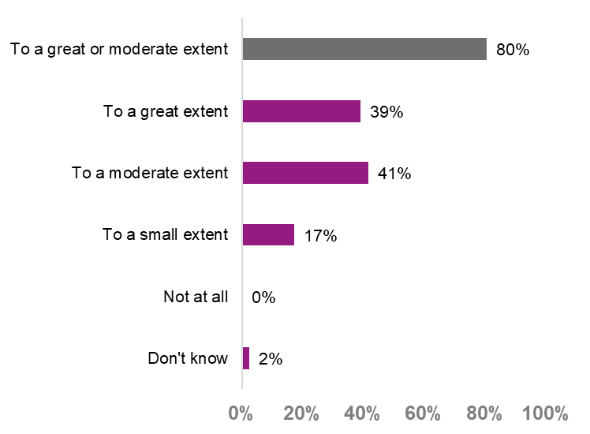
Respondents who said there would be a disruptive impact to at least a small extent were asked if there is anything that could be done to minimise this impact. Their responses touched on the following common themes, although not every respondent made reference to every theme:
- A request to not apply these requirements retrospectively for staff who have already been in their posts for a considerable length of time.
- Requests for more time to implement the requirements. One respondent suggested a time frame of five to seven years, whilst another suggested a series of phased stages, requiring, for example, 50 per cent of applicable staff to be sufficiently qualified within two years, 75 per cent in three years, and 100 per cent in five years.
- Requests for greater clarity on what roles are covered and what qualifications would be fit to meet these requirements, in addition to a clear and well-publicised explanation of the requirements and the timeline for meeting them.
- Requests for exemptions in cases where housing officers already have advanced qualifications in adjacent fields, such as social policy, planning, law, leadership and management and non-accredited training, in addition to relevant applied technical and vocational experience.
- A suggestion that requiring membership in body such as the Chartered Institute of Housing (CIH), with annual CPD requirements, would be more beneficial than requiring a specific level of qualification.
- A request for online learning providers to be signposted or made available which provide sufficient qualifications to meet the requirements.
- An observation that including additional eligibility requirements for future jobs may require increased salaries to offset the risk of long-term job vacancies in a sector where the respondents already report difficulty recruiting suitable candidates.
- Some respondents noted that the disruptive impact would not be entirely negative, as they anticipated some level of increased interest in these roles if they are professionalised and qualifications are guaranteed as a part of in-role learning and development.

Disruptive impacts on service provision
Respondents were asked to what extent they think that the requirements will have a disruptive impact on their service provision.
As Table 9 shows, 68 per cent of respondents anticipated a disruptive impact on service provision resulting from these requirements. This includes 29 per cent who anticipated a greatly disruptive impact, and 39 per cent who anticipated a moderately disruptive impact. As such, fewer respondents anticipated a strong impact on service delivery than those who anticipated an impact on recruitment and retention, although these respondents were still in a majority.
Table 9: To what extent do you anticipate a negative impact on service provision resulting from giving housing officers time to undertake the required qualifications?
 | Number | Per cent
To a great or moderate extent | 28 | 68
To a great extent | 12 | 29
To a moderate extent | 16 | 39
To a small extent | 11 | 27
Not at all | 1 | 2
Don’t know | 1 | 2
Base: all respondents who answered this question (41 respondents).
Figure 3. Anticipated disruptive impacts on service delivery resulting from the requirements
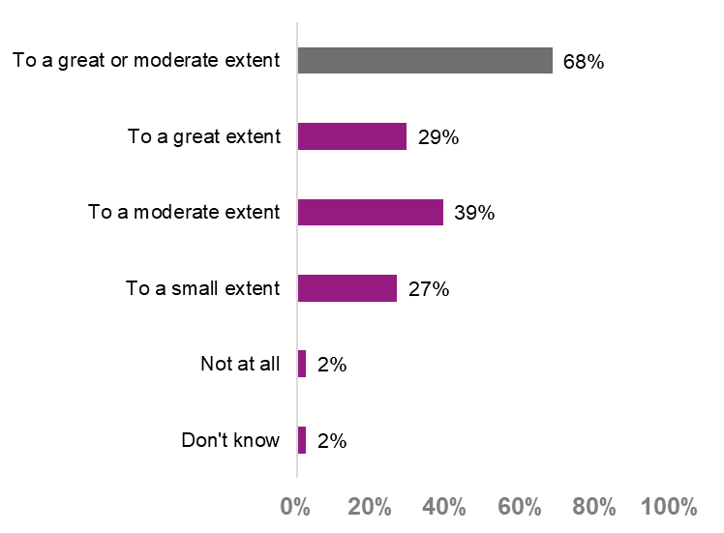
Respondents who said there would be at least a small impact on service delivery were asked if there is anything that could be done to minimise this impact. Their responses generally fell into the following categories:
- A request for new burdens funding to cover the initial cost of courses and membership fees during the transitional period. Several respondents noted that they might need to recruit additional staff to give their existing staff the time required to complete the necessary qualifications.
- A request for a fast-tracking process for senior and experienced staff, to minimise the time they would have to spend in training.
- A request for qualifications which require a portfolio-based assessment which can be embedded within service deliveries, instead of independent module-based assessments.
- A reiteration of the requests to help deal with the impacts on recruitment and retention, including more time to complete the training.

Other potential barriers or issues
Respondents were asked if they foresee any other potential barriers or issues with the implementation of the standards and qualification requirements. Their responses can be grouped into the following broad themes:
- An observation that a qualification is only a “moment in time”, and that Continuing Professional Development (CPD) would be more useful as a standard to meet.
- A note of some potential indirect effects from meeting these requirements, including resources needed to deal with additional complaints from delayed service provision, increased barriers to internal candidates who may not have the required qualifications, and potential resentment and management issues from some staff who may feel well-qualified for their job already and not wish to undertake further study.
- A caution that equality issues might arise from these requirements, as they may impose a greater cost on some social groups than others.
- Observations that a shortage of quality providers for the required qualifications, such as a lack of university courses and sponsorships, may present issues to sufficient number accessing education of the required standard.
They were then asked if there is anything that can be done to minimise the impact of these additional barriers or issues. Their responses are summarised below:
- A request for advanced discussions with colleges and universities, for greater clarity on what qualifications meet the required standards and how providers of education can be supported to offer the required quality and volume of appropriate training.
- A request to make training attractive, engaging and available in a wide range of different formats.
- A request to broaden the range of qualifications considered acceptable, to recognise the diversity of skills suitable for the housing sector.
- A request for the process of skills assurance to be directed more by local housing providers monitoring their own workforce than a centralised, top-down set of standards.
- A reiteration of observations and requests already mentioned above, such as requests for additional time to meet the required levels, considering making exceptions for experienced and long-serving staff, and the alternative of a CPD-based approach.

Annex A: Questionnaire
Professionalisation of Housing - Survey of local authorities
The Regulator will be setting broad, outcomes-focused competence and conduct standards which will apply to all staff delivering housing management services, requiring providers to ensure staff have the correct skills, knowledge, experience and behaviours needed to deliver a high-quality professional service. As part of these standards, there will also be a requirement which will only apply to a specific subset of staff to possess mandatory qualifications.
As part of this, the Social Housing (Regulation) Bill, Amendment 13 aims to professionalise housing management, asking relevant staff to complete qualifications up to a certain level.
In advance of a public consultation and stakeholder roundtables, the LGA has created a survey which will form a snapshot of how this amendment might affect the sector and relevant stakeholders. This survey will help us to understand any challenges that these new requirements will pose for local authorities, to help us lobby for support through this transition.
This survey relates to terms and concepts with precise legal definitions - if helpful you can click the following link to download a summary of these legal definitions.
All responses will be treated confidentially. Information will be aggregated, and no individual or authority will be identified in any publications without your consent. Identifiable information may be used internally within the LGA but will only be held and processed in accordance with our privacy statement. We are undertaking this survey to aid the legitimate interests of the LGA in supporting and representing authorities.
Meeting the mandatory qualification requirement
The new law will require local authority senior housing executives to hold qualifications regulated by the Office of Examinations and Qualifications Regulation (Ofqual) at mandatory minimum standards.

- How many of your current senior housing managers are already qualified to the level required by the new legislation?

Please provide the number of senior housing managers at your authority (or your ALMOs, TMOs or housing management contractor's housing manager or housing executive) who are already sufficiently qualified, and the number who are not. The total should add up to the total number of senior housing managers at your authority.

Number of senior housing managers already sufficiently qualified:
Number of senior housing managers not yet sufficiently qualified:

- How many of your current senior housing executives are already qualified to the level required by the new legislation?

Please provide the number of senior housing executives at your authority (or your ALMOs, TMOs or housing management contractor's housing manager or housing executive)who are already sufficiently qualified, and the number who are not. The total should add up to the total number of senior housing executives at your authority.

Number of senior housing executives already sufficiently qualified:
Number of senior housing executives not yet sufficiently qualified:

- How confident are you that you have accurately estimated the number of qualified housing officers above?

Very confident
Fairly confident
Not very confident
Not at all confident
Don’t know

If lack of confidence (not very or not at all) is indicated:

Please explain your lack of confidence in these figures, and what you might need in order to achieve greater certainty.

____________

- How many housing officers do you think you could support to undertake the required qualifications over a two-year period, based on your current resources?

____________

- Please estimate the likely additional cost to your local authority over the first two-year period, resulting directly from these new requirements, in total GBP.

____________

- Please estimate any additional annual costs to your local authority expected after the first two-year period, in GBP per year.

____________

- To what extent do you think that these requirements will have a disruptive impact on your recruitment and retention of housing officers?
To a great extent
To a moderate extent
To a small extent
Not at all
Don’t know

If disruptive impact to at least a small extent is indicated:

Is there anything that could be done to minimise this disruptive impact? Please share any thoughts below.

____________

- To what extent do you anticipate a negative impact on service provision resulting from giving housing officers time to undertake the required qualifications?

To a great extent
To a moderate extent
To a small extent
Not at all
Don’t know

If disruptive impact to at least a small extent is indicated:

Is there anything that could be done to minimise this disruptive impact? Please share any thoughts below.

____________

- Are there any other potential barriers or issues with implementation of the standards and the qualification requirements that you foresee?

____________

If any response is provided to Question 9:

Is there anything that could be done to minimise these barriers or issues? Please share any thoughts below.
____________



Local Government Association
Local Government House
Smith Square
London SW1P 3HZ
Telephone 020 7664 3000
Fax 020 7664 3030
Email info@local.gov.uk
www.local.gov.uk
© Local Government Association, June 2023

